**For Immediate Release**

**AIR Music Tech Unveils AIR Sub Factory:  
The Ultimate Bass Synth**

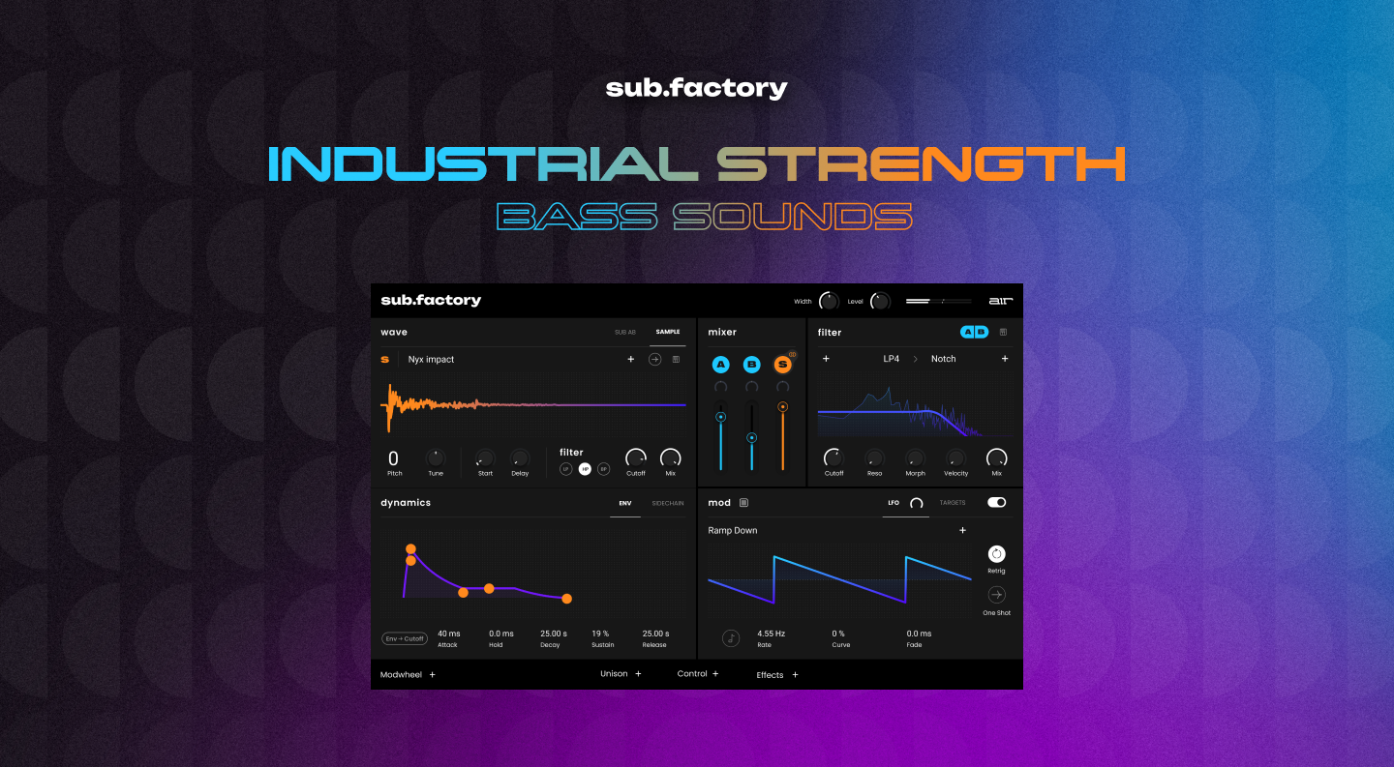

**Cumberland, RI, August 8, 2024 — In celebration of this year’s annual 808 Day, AIR Music Tech has announced the release of the AIR Sub Factory, a synthesizer designed for creating industrial-strength bass sounds. This synthesizer is aimed at producers who value well-crafted bass lines, offering versatile capabilities and advanced features.**

The AIR Sub Factory extends beyond classic 808 bass presets, offering a broad range of sounds suitable for various genres such as R&B, Hip Hop, Drum and Bass, and Pop. The dual wavetable engines and additional sample engine provide producers with extensive control over their bass sounds.

The core of AIR Sub Factory includes dual wavetable engines with hundreds of waves ranging from classic analogue to hybrid sounds. Each wave features 127 index points for detailed customization. Additionally, a third sample-based engine offers a variety of kick, 808 loops, shots, noise, and FX samples with features like sample start and delay, reverse, pitch, and filter adjustments.

**Advanced Sound Design**AIR Sub Factory includes intricate filters, dedicated pitch controls, and comprehensive amp and filter envelopes. The modulation section with a wide array of target options allows producers to create unique sounds. The synthesizer comes with a library of presets designed to inspire creativity. For those who prefer to start from scratch, AIR Sub Factory offers extensive controls for detailed sound design.

**Built-in Effects**AIR Sub Factory includes effects such as Unison, Spread, Width, Ring Mod, Chorus, Drive, and EQ, providing tools to enhance and polish the sound.

Neal Gustafson of AIR Music Tech commented, “AIR Sub Factory offers comprehensive features that cater to both immediate use and detailed exploration, making it a valuable addition for music producers focusing on bass production.”

**Formats:**

* **macOS:** AU, VST, VST3, AAX
* **Windows:** VST, VST3, AAX
* **MPC Standalone:** One, Live, Live II, X, Key 61, One+, Key 37

**Pricing & Demo**The AIR Sub Factory is available for $79.99, with an introductory promo price of $39.99 until September 5th. A 10-day demo can be downloaded from [AIR Music Tech](https://www.airmusictech.com/virtual-instruments/sub-factory).

**About AIR Music Tech**One of the earliest pioneers in virtual instrument technology, AIR is dedicated to creating the world’s most advanced and easy-to-use virtual instruments. Our team is responsible for the core of much of the effects offerings in Avid’s Pro Tools ® software.

###

Hunter Williams

+1 (518) 534-9170

hunter@hummingbirdmedia.com